# Media Analysis - ChatGPT outperforms copywriters in STEP Conference’s outdoor adverts _ Updated 22 February 2023

## Short Summary

The article is about the integration of ChatGPT into tech festival STEP Conferences outdoor adverts, highlighting its impact on creative industries and the company s plans to continue using AI tools for content creation.

## Summary

* ChatGPT outperforms copywriters in STEP Conferences outdoor ads.  
* The company plans to continue using AI tool for content creation, summarizing and explaining.  
* Dargham sees a complementary role for AI tools alongside human talent, acknowledging the potential for both replacement and augmentation of certain tasks.

## Question 1

The media, in this case the sample of outdoor advertisements and tech festival STEP Conferences, frames the public discussion about ChatGPT mainly as a demonstration of artificial intelligence s capabilities. The ads featuring taglines generated by ChatGPT showcase its creative potential in crafting catchy phrases. In this context, certain **metaphors** keep cropping up to describe ChatGPT s performance 1. Creative Brain Advertisements emphasize ChatGPT s artificial intelligence assistant status, likening it to a creative and intelligent brain. 2. Problem Solver The media often portrays ChatGPT as a solution-focused tool that can generate content or ideas for a wide range of tasks. 3. Evolutionary Leap Articles discussing the implications of AI tools like ChatGPT often use the metaphor of an evolutionary leap, suggesting that these technologies represent significant advancements in human capabilities. Overall, the media s framing of ChatGPT publically emphasizes its creative and problem-solving potential while using metaphors to convey the significance of this AI tool.

## Question 2

The perspective and aspects being widely covered in the topic include 1. Adoption and impact on creative industries The use of ChatGPT in tech festival STEP Conferences outdoor adverts is a focal point. 2. Role of AI as a tool for efficiency and content creation The discussion about how AI complements human talent and its potential to replace certain tasks. 3. Future implications and concerns The mention of existential threats posed by AI, the evolving landscape of other AI tools, and the impact on job markets. However, some aspects that might be considered are being ignored or not as extensively covered 1. Ethical considerations and regulations surrounding AI use While the existential threat is mentioned, a deeper dive into ethical implications might have been relevant. 2. The learning curve for individuals and teams in adopting AI tools like ChatGPT This aspect could have delved into potential challenges users face while integrating these tools into their workflow. 3. The short- and long-term effects of AI on the job market, specifically addressing how job displacement might be offset by new roles created by AI adoption. In summary, the topic widely covers aspects related to AI s impact on creative industries and its potential to replace human tasks. However, there are aspects like ethical considerations, learning curves, and employment dynamics that could have received more attention.

## Question 3

The Arabic World is mentioned in the context of the tech festival STEP Conferences taking place in Dubai. The festival apparently leverages AI through ChatGPT, which helps create outdoor adverts and other content. However, it s important to note that while the Arabic World plays a role in the context of this article, the broader implications and uses of AI are not limited to any one region.

## Question 4

The final message is that AI tools like ChatGPT will both augment and replace human work, but human creativity will remain invaluable.

## Sentiment

The sentiment is 3.0

## Entities

Dargham, STEP Conferences, Metas Open Pretrained Transformer, Dargham clari ed, Art, Ray Dargham, Arab News, Microsofts Bing, STEP Conference, Googles Bard, STEP

## Highlights

#7cc867#f9cd59#c885da#fb5b89

## Wordcloud for #7cc867 Highlights

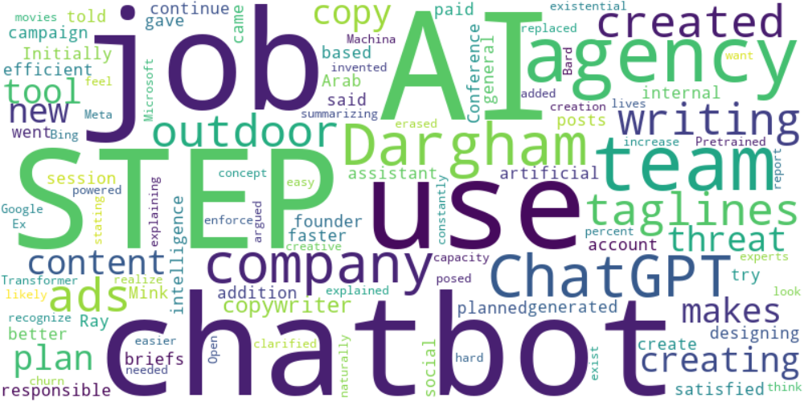

Top 10 words:

- AI: 6

- STEP: 5

- use: 4

- agency: 4

- team: 4

- like: 4

- Dargham: 3

- ChatGPT: 3

- company: 3

- chatbots: 3

## Wordcloud for #f9cd59 Highlights

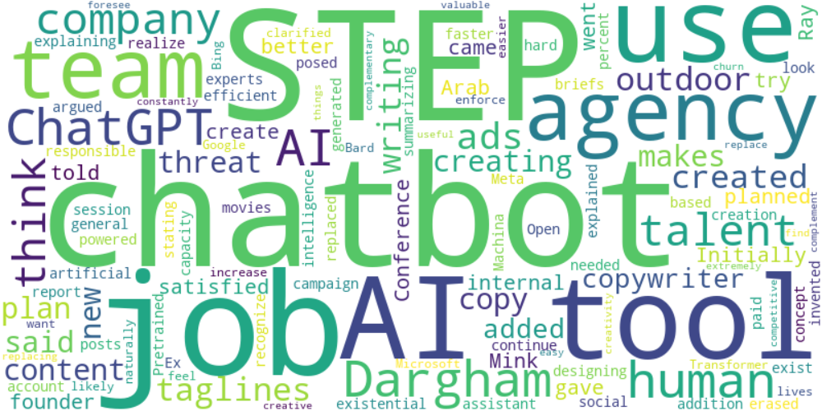

Top 10 words:

- AI: 9

- STEP: 5

- use: 4

- agency: 4

- team: 4

- Dargham: 4

- ChatGPT: 4

- like: 4

- tools: 4

- company: 3

## Wordcloud for #c885da Highlights



Top 10 words:

- AI: 6

- STEP: 5

- use: 4

- agency: 4

- team: 4

- like: 4

- Dargham: 3

- ChatGPT: 3

- company: 3

- chatbots: 3

## Wordcloud for #fb5b89 Highlights



Top 10 words:

- AI: 6

- STEP: 5

- use: 4

- agency: 4

- team: 4

- like: 4

- Dargham: 3

- ChatGPT: 3

- company: 3

- chatbots: 3